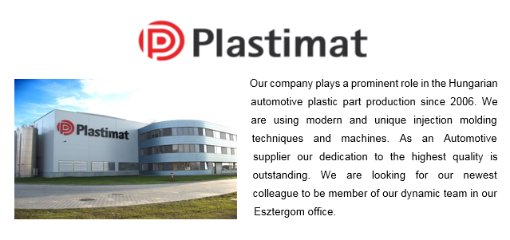
quality system engineer

RESPONSIBILITIES:
- Being the central contact point for developing, managing and maintaining the QA system, maintaining the documentation as well
- Developing and managing QA processes and systems regarding the standards (IATF 16949, ISO 14001, ISO 18001)
- Participation in quality management issues,
- Performs the tasks according to Automotive Quality Management system and makes proposal for its improvement, especially in adherence to customer requirements
- Managing regularly internal audits (system, process, product and 5S)
- Active participation in audits – in preparations, coordination, delivering and reporting

requirements:
- Collage/University degree in Quality management, (Manufacturing, Mechanical, or Industrial Engineering)
- Minimum of three years’ experience in a manufacturing environment required with preference to the automotive industry
- Knowledge of Automotive Standards as IATF 16949:2016 is a must!
- Knowledge of ISO 14001 and ISO 18001 standards
- Knowledge of quality techniques, participation in specific problem solving processes
- Ability to solve complex problems
- Advanced English language knowledge (because of the close contact with the HQ)
- Accurate, precise personality

ADVANTAGES:
- Experience in automotive plastic industry

WHAT WE OFFER:
- International, stable manufactory background in Automotive industry
- Employee-friendly environment, dynamic team
- Competitive salary

PLACE OF WORK:
- Esztergom (45 km from Budapest)

BE THE MEMBER ONE OF THE LARGEST PLAYERS IN CAR INTERIORS MARKET!
SEND YOUR CV TO US TODAY:
monika.toth@grupoantolin.com

